Before you open the project, you have to install:

Visa driver for LabVIEW

<http://www.ni.com/download/ni-visa-18.0/7597/en/> //for 2018 version

tis project is composed of two parties: LabVIEW for data processing, keypad to enter the security code and Arduino to send those data processed by LabVIEW to actuators like Servo to open, led and the buzzer.

So, what you need is that read the code coming from the keypad via Arduino and then read character by character in LabVIEW containing the preconfigured password.

If all the digits and alphabets are correct then LabVIEW sends a character like” o” (means open door) to Arduino via serial and the Arduino in her side send it to the actuators (led =green, no sound coming from buzzer and servo rotating to open the door).

Else LabVIEW sends another character like “n” (don’t open the door and start the alarm)

(led= red, buzzer on, door still closed).

For the code in arduino it’s very simple

You initialize the serial port Serial.begin(9600)

Then you test is the serial is available (Serial. available()>0)

You read the character Serial.read()

Then corresponding to this charater you’ll do an action (open the door, turn on buzzer ….)

LabVIEW part:

Chose in the coloured zone the COM corresponding to the Arduino

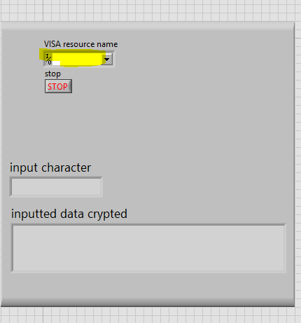

Turn on if the character entered is true

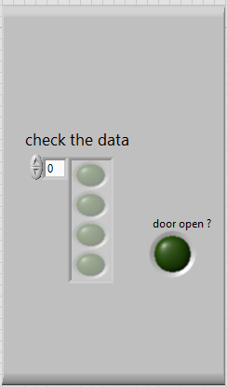

The image of actuators changes corresponding to the action and condition putted in the program

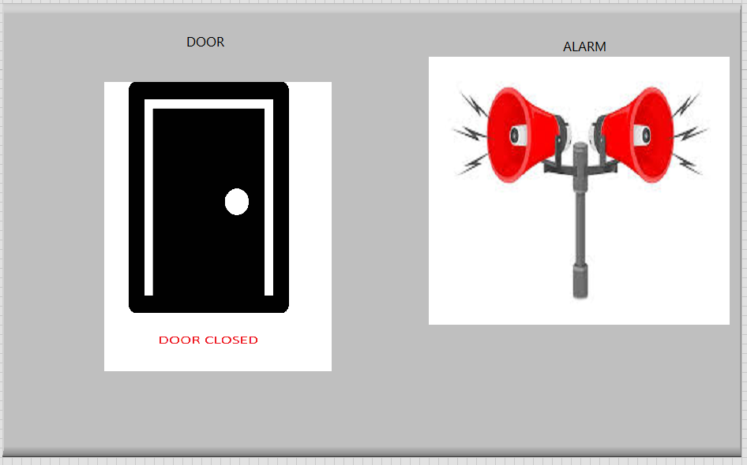

Hope I explain everything, if you didn’t understand something please contact me